**User defined variable:**

First record the teat using blazemeter,then open in JMeter.

While testing on the page I selected the paris and other destination area while recording.

But by using the User variable we can change the requirements as user wants.we can see as given below.

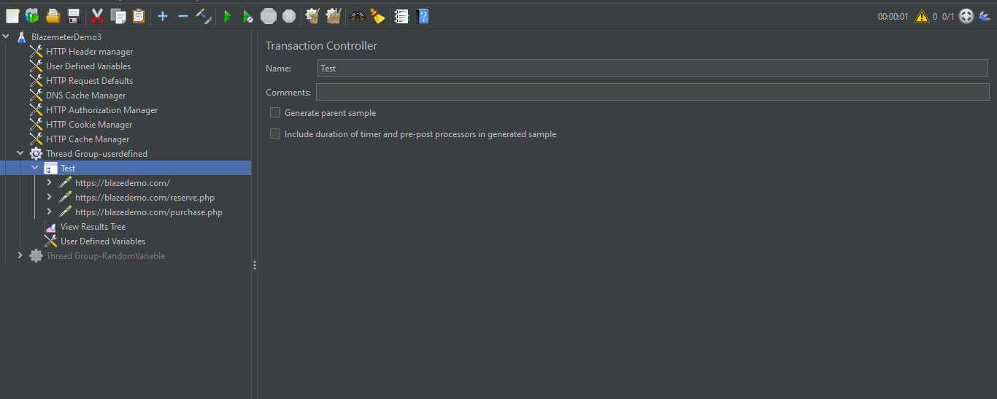

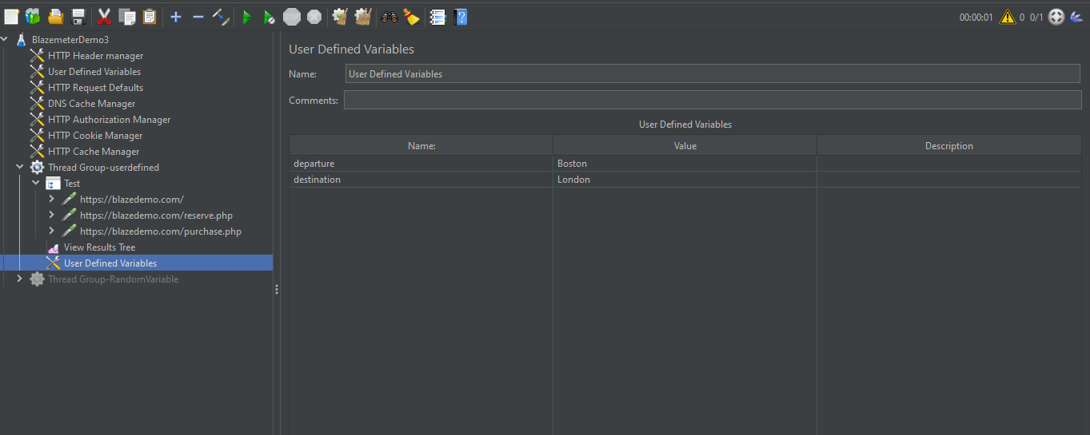

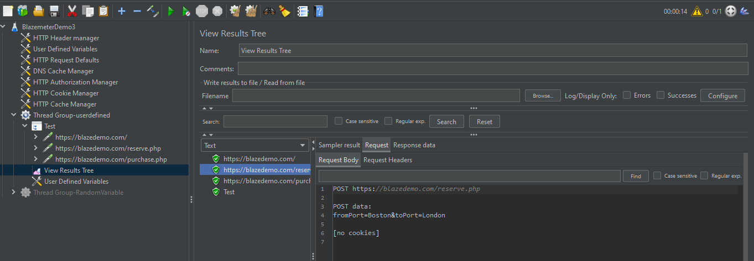

**Random Variable:**

In random variable maximum limit I gave 10 ,so its executed 10 times randomly.We can see the tests are executed as given below.

